# **Everything you need to know about derivatives**

This document requires that you’ve read and understood “EYTNKA limits”. If clarification of what a derivative is intuitively is needed, then look at khan academy.

The formulas for a derivative used in class are

With these you’ll need know

* How to find the derivative any polynomial or rational polynomial (both generalised and for a specific point).
* How to use them in the “properties of derivatives” section
* How to do higher order derivatives
* To prove some standard derivatives, like log, e^x, trig, etc.
* Implicit differentiation
* Some important theorems (ex. MVT)
* Some standard derivatives to memories form the trig functions and Euler’s number

Important thing to distinguish is when to use the first or second formula. You’ll see when a couple of examples are worked out.

You should also get the difference between differentiation and derivative, since a question on the exam might try to catch out on that:

* Differentiation: Show the limit exists
* Derivative: find the derivative of a function. Note that if we give a certain point (ex. x = 3 or x = 0), then we could plug that into the equation!!! That could massively simplify your equation. This holds whether we’re doing the derivative explicitly or implicitly.

Finally, there are a lot of theorems linked to this section. If there’s a star beside the name, you must memories the theorem. If I underline the theorem in the title, it is the proper name of the theorem. If not, then it’s a name I made as a pneumonic.

BTW, if you’re in Tyler Holden’s class, he likes his as

# **How to use derivative**

We’ll start by exploring how to use derivatives and prove why we could use them in this way

## **Notation**

You know all of the notation, so I’ll skip it for know (p.s. Newtonian = physics, lagrance = short, Leibniz = fraction)

For higher order derivative

Lagrange: once it’s higher than 4:

Leibniz:

## **Properties of derivatives\***

Suppose are differentiable at c and then

1. If is differentiable at c,
2. If is differentiable at c,
3. If is differentiable at c,
   1. This property could be expanded:
4. (extension of 3) If is differentiable at c,
5. (extension of 5):

We might need to prove these on the exam so:

Proof of 1:

Proof of 2: . For this one, you rearrange:

Proof of 3: . This one needs more than rearranging. We also add a clever 0.

Evaluate the limit

Proof of extension on 3:

We use induction to prove this. We’ll take advantage of the binomial theorem?

Base case: Just proved in the previous proof

Inductive case: assume

(TBD, moved on to more important things for now)

Proof of 4:

This one is based just the product rule on , where g^-1 is 1/g , not inverse of g.

Proof of 5:

Here

Proof of extension of 5

here

## **Higher order derivatives**

Given are both differentiable, is the second derivative

This concept is pretty self explanatory.

## **differentiable? Then continuous**

This theorem states that if you got a function that is differentiable, it implies that the function is continuous, which make intuitive sense. You should know this in case we know a function is differentiable and the question is asking something that requires continuity.

For this theorem, we’ll build it starting from the fact that a function is continuous, and thus

From this, we want to go towards a differentiable function. To do this, we’ll re-arrange and multiply by fancy ones till we get there.

This is almost a differentiable function. Use the limit properties:

Notice that we’ve gotten one of the definition of a limit, and 0 on the right. However, we’ve not gotten actually changed this from the continuous function requirement, so since this is true, it must be the case that a differentiable function is continuous.

Note that a continuous function does not imply differentiability

Ex:

# **Proof of common derivatives**

In this section, we prove a couple of common derivatives, and a couple of tricks to solving them

## Proof of polynomial

You could do it yourself

## **Prove of derivative of sine and cosine\***

A hint to remember these. Remember double angle identieis and **\*lim(x->0) sin(x)/x \***

Plug in . Note that = 1[1]

Similar proof for , except use

## **Prove the derivative of \***

For this class, we’ve defined the Euler’s number to be the unique number such that

So you don’t need to know the finance formula for it now, nor the Taylor series for it (at least when I wrote this).

Thm: the function is everywhere differentiable and

Proof:

## **inverse functions theorem [IFT]\***

We don’t need to know the forma derivation of the IFT, but if you want it at p.305 in Tyler’s book and in Spivak’s book p.__.

To take the derivative of an inverse function, there’s a handy trick you could use.

For this IFT to be usable, three conditions must hold:

1. is differentiable at x
2. is continuous at x
3. :

The IFT also could be used that the inverse function is differentiable

Note that a consequence of this is

This is technically not because it is a fraction, but because of the inverse function theorem.

### **Prove derivative of log with [IFT]\***

This is useful to prove

Thm: is differentiable everywhere

Proof: We need to set the right values to use the IFT

set

NOTE: is never 0, so it satisfies

So, by IFT, log is everywhere differentiable.

Note that this is generalize to

And could be taken one level further to

Remember that log(a) means ln(a) for Tyler.

### **Prove derivative of inverse trig functions with [IFT]\***

This is useful to prove

Note that for the function sin to be invertible, you must restrain the domain. Look at bijection if this looks weird:

Thm: is differentiable at (-1,1) and

Proof: We need to set the right values to use the IFT

Set

Note that is an open interval, and that cos(x) will always be greater than 0.

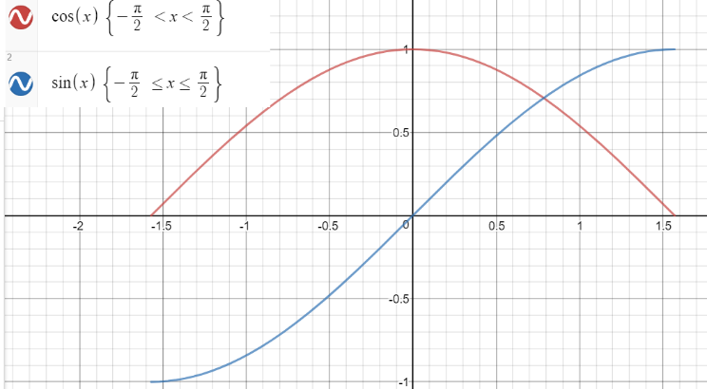

This is important! We can’t have be 0, less the IFT fraction won’t hold.

So, by IFT, arcsine is everywhere differentiable.

To compute cos(arcsine(x)), we need to think about trigonometric tricks, most likely identities and play around with them. Fortunately for us, the simplest identity is the one we need and so our exploration is very quick:

Remember that we’ve restricted the domain of x, so the root might be strictly negative or positive! This is something you MUST check if your domain is restricted. In our case, it is positive (check yourself if you’re curious)

Now we could plug in

Q.E.D.

This could be done for as well, and same for tan but with the equivalent

# **Implicit Differentiation**

This concept isn’t rigorously defined in class. You know this, but some extra insights where given in class. We’ll start with the obvious:

Implicit functions: Don’t necessarily pass the vertical line test

Explicit functions: must pass the vertical line test. i.e.

Ex: find the derivative with respect to x of:

Proof: (you know how to get from circle to y’)

Naturally, if you solve explicitly, you have less information. However, there’s an interesting substitution you can do that you didn’t know about:

We’ll work with the positives[2], so

Notice the denominator is y, so we can substitute it in!

Notice that in this example, we didn’t give the point at which we’re differentiating. Let’s do another example where we do. This is just to get used to the fact that if a point is given to us, you can massively simplify your equation, as stated at the beginning of this paper!

Ex. find when y = 0 [3]

Plug in y = 0

Now that we know what value ‘x’ is when ‘y’ is 0, we could more easily find the derivative:

We’ve found that when y = 0, x = 0

Also, a shortcut for finding here would be the one stated in the IFT section. So

## **Logarithmic differentiation**

This is an extension of implicit differentiation following a nice property of logs:

This decrease’s arithmetic complexity, especially when there’s a lot powers or . In a way, this is a shortcut to raising everything to the power of or the [IFT].

Ex:

Let y =

Sub back in

Now I know that this will be difficult to spot when to use, since you could do it the other way, but do some exercise to see if you could build up your gut-feeling on when to use this. You should look for:

Which I will let you derive yourself. The answer is:

## **Related rates**

As you know, “Related rates” is a concept that lets you link static variable to dynamic variable. In Tyler’s words: “Use static equations to find the dynamic relation trough implicit differentiation”.

To demonstrate this, we’ll use an example and go through the methodology of efficiently solving a related rates problem, including the archetypical one:

***Example***: suppose a 5-meter latter is leaning against a wall. The base is being pulled out at 0.5 m/s. Determine how quickly the top of the latter is falling when it’s 3 meters from the ground.

Solution:

1. Establish your goal. For this case, we want to find at . This step could coincide with step 3, but it could help in the visuals if you have an idea of the wanted end result. We also want to know what our final result will be related to, which might not always be obvious, but a guess that isn’t taken too seriously could be made.
2. Draw an image of the problem. It will make it clearer what you’re seeking out. Projective images could also be used if no information is lost in the math and it’s still clear.

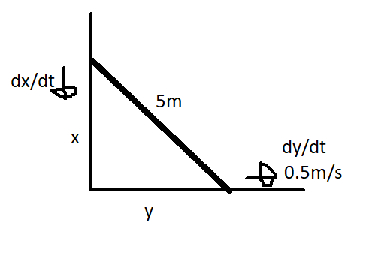

1. Now we define all our variable. A good idea would be to find the derivative of the useful variables as well (some might have useful properties, like being constant). In this image, we’ve defined and the hypotenuse. Notice that if we wanted we could’ve defined the angle ), and , and if we couldn’t figure it out with the information at hand, we would’ve considered those variables to see if we could find more information.
2. Find all the relationships you find useful. Now that we’ve gotten our variable, we want to link them! Note that the structure of the situation could affect the types of equation you want to use to link variable. In this case, there are two very easy equations:
3. Start thinking of ways you could reach your goal. Manipulate your equation and plug numbers in. Try to get rid of all unknown variables except the one you’re looking for:

We want to find when x = 3. We know , x, but not y. We could figure it out through

And the problem has been solved. Note that this is not the unique way to get to this solution. We could have tried to go through

And so on. However, we introduce a which complicates the equation. Be mindful of faster ways.

Example 2: Consider a rectangular pyramid whose base is a square with width, length, and height L. Suppose we’re filling it with grain s.t. the height of the grain is filling at a constant speed. What’s the equation for the difference of volume of grain with respect to time?

Solution: we’ll follow the steps pointed out earlier

1. The rate at which the grain is entering the pyramid must be slowing down since the . So the more there is, the less the volume of the grain in the pyramid will grow. We want to find an equation for , which is related to h.
2. This image is an example of a projection. A pyramid is hard to draw on paint…

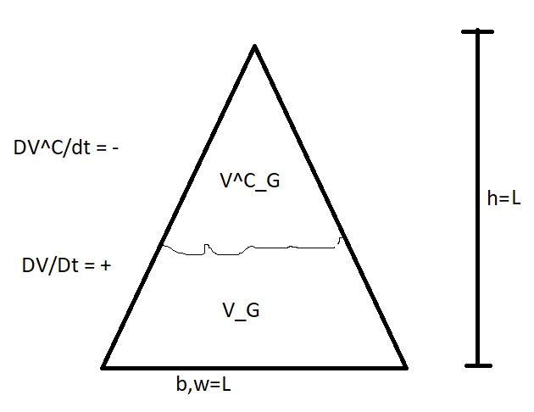

1. The variable we have are base (b), width (w), and height (h), height of grain , all equal to , volume of current grain , volume of what’s left to fill i.e. compliment , , , and total volume (which I forgot to indicate on the image).
2. Establish known formulas
3. Plug in and manipulate

Is equivalent to

We know is constant:

And like that, we’ve found the relationship we wanted.

Do more example to optimise the methodology. And don’t forget to add those derivatives!

# **Optimization**

You know the intuition. Note that an increasing function isn’t defined by the derivative but if the derivative exists, you could use it to find an increasing function.

## **Maxima and minima**

You need to write this down because it comes in handy for proving the MVT, which I’ll move not for know (this is proving critical points)

## **Lagrange theorem\***

About the existence of critical points. Used in solving Rolle’s theorem

## **First derivative test**

Check positive/negative on bot sides of the critical point

## **Second derivative test**

Do the second derivative. Positive = minimum, negative = maximum, zero = inflection point

My trick: happy face = positive = minimum, sad face = negative = maximum

## **optimization**

This section takes the previous parts and combines them. There are two forms of optimization:

* Unconstrained optimization:
* Constrained optimization:

# **Mean Value Theorem [MVT] (*?)**

If is continuous and

If is differentiable

Then

This theorem states fancily what you already know. Khan Academy video did a good job explaining the concept. The use of this theorem is immense; it relates something that looks like the derivative but isn’t, to an actual derivative. Or, as Tyler put it

“The MVT says that a point whose tangent line slop is the sequent line slope”

To prove this, we need to go through a similar theorem, and then generalise it:

## **Rolle’s Theorem\***

if is continuous on and differentiable on and (and a =! b, tyler)

This is different from the MVT because of the third condition. Visually, you get

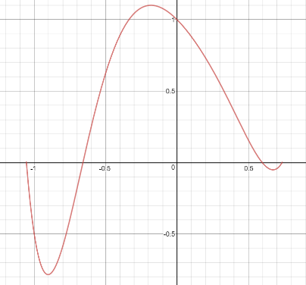

After proving this, it will be easier to the MVT.

Proof:

Let

If f is constant, then . And this confirms the case we want, and we’re done for this trivial valued function.

If f is not constant, then since it’s continuous on [a,b] by EVT, achieves both it’s max and min. If you’re fuzzy on the EVT (extreme value theorem), then refer to the “everything you need to know about value theorems paper”.

Since is not constant, one of the {max, min} is not , hence

Now by the Lagrange theorem, we know that , which proves Rolle’s Theorem

For a visual demonstration:

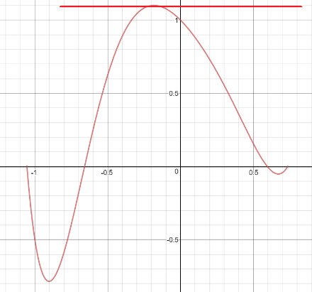

This theorem could be used exclusively to solve problem that might be asked on the exam.

Ex. Show that has exactly 1 root (we’re f(x) = 0).

Solution:

We could use the IVT (intermediate value theorem) to show that there exists a root:

We want to show this is the only root. We could prove this directly, via contradiction, via contrapositive, and so forth. You can’t really tell which until you’ve mastered the art of knowing when to use the theorem. Fortunately, we’re told that the most common way to use Rolle’s theorem to prove this is to use proof by contradiction.

Assume there’s more than 1 root. So, pick two distinct roots and (to make the math easier).

is continuous on [], and is differentiable on , and , so by Rolle’s theorem, . However, is a strictly increasing function, therefor it is impossible for it’s derivative to equal 0, therefor there’s a contradiction!

Get comfortable in recognising situation where Rolle’s theorem comes into play.

## **Proof of MVT*?**

Let’s bring back the definition of the MVT:

If is continuous and

If is differentiable

Then

To show how we get from Rolle’s theorem to the MVT, I’ll use visual aid using f(x) = sin(x) +x:

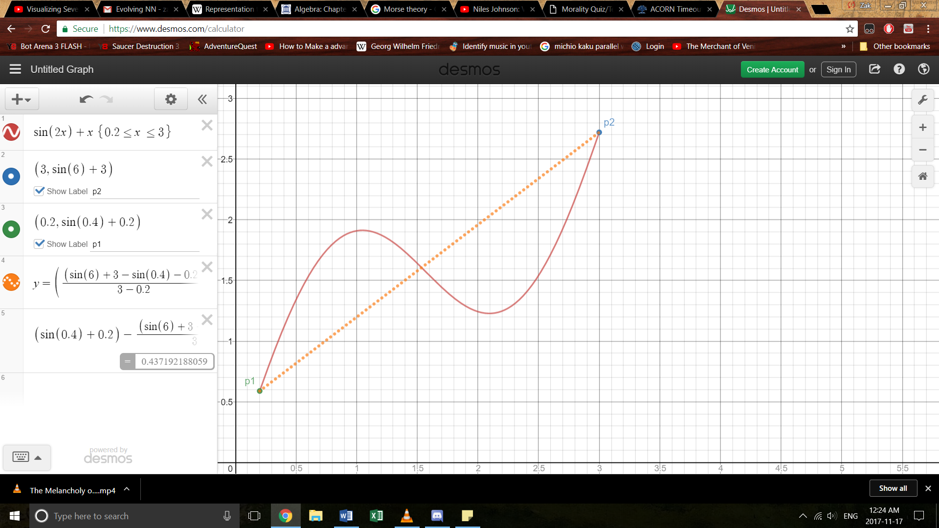 -> 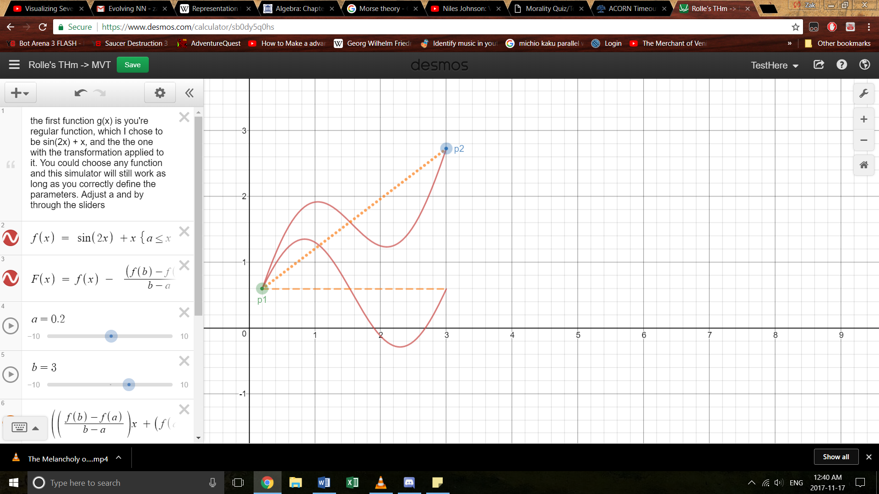

We essentially want to bring the function to a point where we could use the Rolle’s theorem. For a more hands on approach to this, I’ve made a dynamic desmos graph that will bring any legal function[4] to a state where you could use Rolle’s Theorem.

<https://www.desmos.com/calculator/9jywgrekpk>

or with the points moving

<https://www.desmos.com/calculator/anlazyo9p0>

The function which does this transition is in the visual transformation is:

Notice that is still continuous on [a,b] and differentiable on (a,b), and

This property makes it compatible to use Rolle’s Theorem. So by Rolle’s Theorem

This is the statement we set out to prove

There’s a corollary of this theorem that, according to Tyler, is often on the exam:

Proof:

what does it mean for a function to be constant? It means that

This next section is essential to be written down in full on an exam to get full marks:

Choose some . is continuous on and is differentiable on so by MVT

Since x = a

# **L'Hôpital’s rule**

Also known as l’Hôspital’s rule, it states the following:

Suppose

There’s a whole proof, but we need not know it. I’ll write it down if I have the time.

Example of use:

This is type THIS IS IMPORTANT TO POINT OUT ON THE EXAM. ‘Types’ are explored in the next section. With this you could say this

You can use l’Hôpital’s rule many times in a row if necessary

HERE

Beware of L’Hôpital rule power. Many students use it as a sledge hammer to solve many problems, but the teacher could easily construct a function that will be easy to solve, but turn into a monstrosity if you try to use l’Hôpital’s rule.

## **Variations of l’Hôpital’s rule**

There are around 30 variations, which sum up to say you could use this rule in basically any case:

* Then you could combine these case with ,
* Then you could combine all of those cases with

So, a lot of possible cases

## **Indeterminate type test**

Indeterminate types are when a value of an expression approaches un-defined values (ex. ). There’s a special way of dealing with them. The idea behind many of these is to see what value ‘wins’ (ex. ; 0 or infinity wins?). Note that many of these are resolved by manipulating them into a from in which l’Hôpital’s rule is usable.

|  |  |
| --- | --- |
|  | When you encounter this indeterminate type, you can use l’Hôpital’s rule |
|  | When you encounter this indeterminate type, you can use a variation of l’Hôpital’s rule |

These are indeterminate type that need more work to solve

|  |  |
| --- | --- |
| **Indeterminate expression** | **Strategy** |
|  | No general strategy. Watch Mathloger’s video on    <https://www.youtube.com/watch?v=-EtHF5ND3_s>  However, you could still manipulate to create a case. Use your brain  Ex.  This is now a . Use l’Hôpital’s rule |
|  | Suppose  Rewrite as either  Left expression = l’Hôpital’s rule  Right expression = l’Hôpital’s rule variation  Ex. |
|  | Suppose  Now we got a type. Refer to previous indeterminate type. Once you find this value (let it be for know)  Ex.  Solution:  Set  Manipulating and using l’Hôpital’s rule, we get a |
|  | NOT AN INDETERMINATE TYPE, always approaches 0 |
|  | INTUITIVE INDETERMINATE TYPE, always approaches definite value. You can treat these with common sense. Ex: |

# **Graph Sketching**

This section outlines all the tricks to turn a 1d function into a 1d graph represented on a 2d surface. You don’t need to do every trick every time you sketch a graph. Choose the correct ones depending on the function:

* Domain and range
* X- and y- intercepts
* Symmetry; such as even-odd or periodic behavior
* Horizontal, vertical, and other non-constant asymptotic
* Critical points and intervals of increase/decreasing
* Extreme points
* Inflection points and concavity.

## Oblique asymptotes

Oblique asymptotes are calculated in the following manner. Let:

We know that lim x -> infinity = infinity, -infinity = -infinity (test the numbers)

Now. This gives us 2x-1 as a good candidate for the oblique asymptote. So do:

If it equals zero, then it’s an oblique asymptote

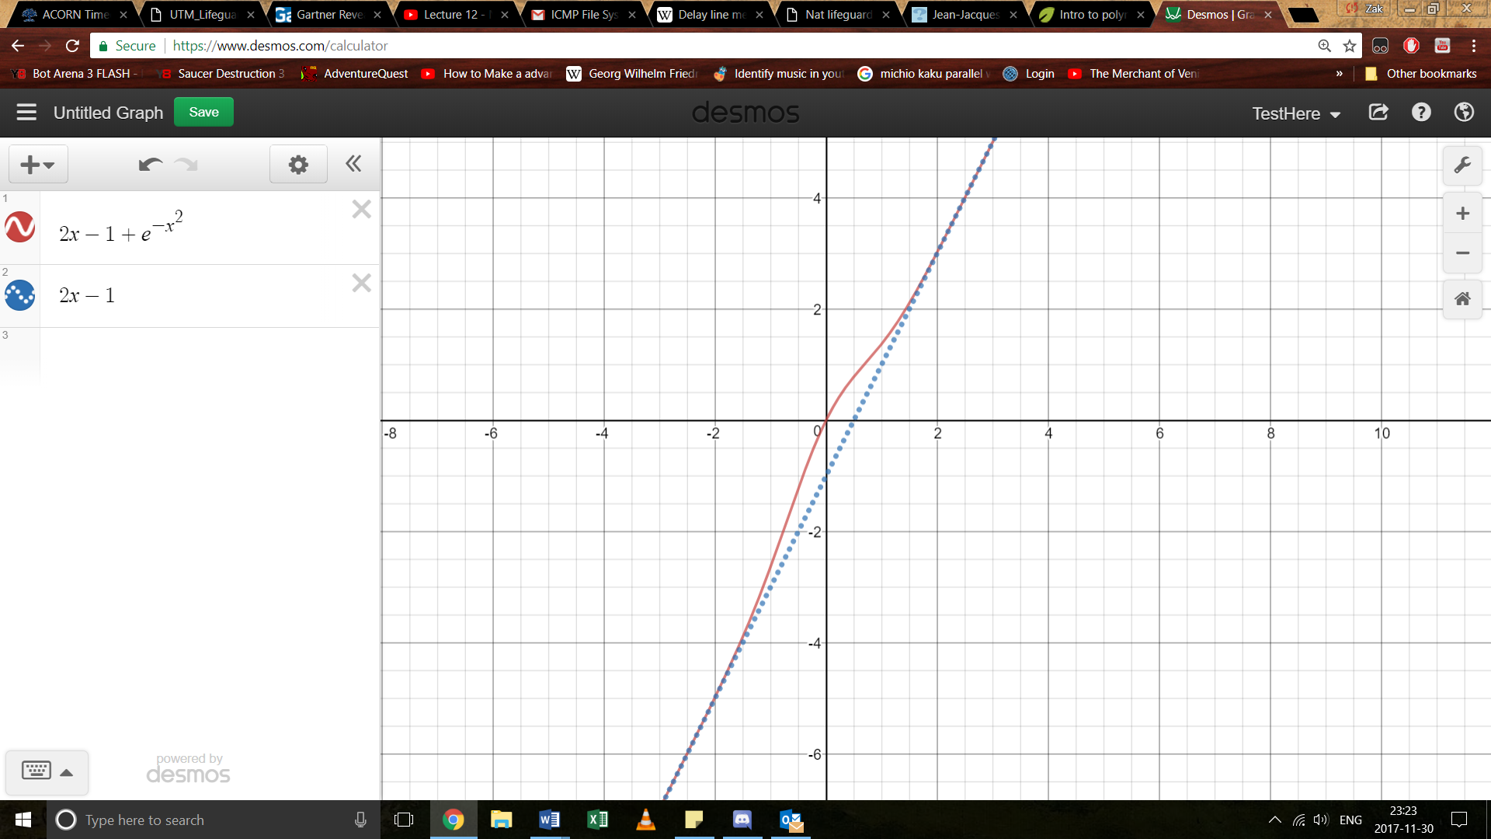

If nothing is obvious like:

Then try to just substract ‘x’ and see what you get

L’hopitals rule

Sine this value is off by a constant, it signifies that this to make the oblique asymptote equation accurate, we’d need to move up by 1. Therefor

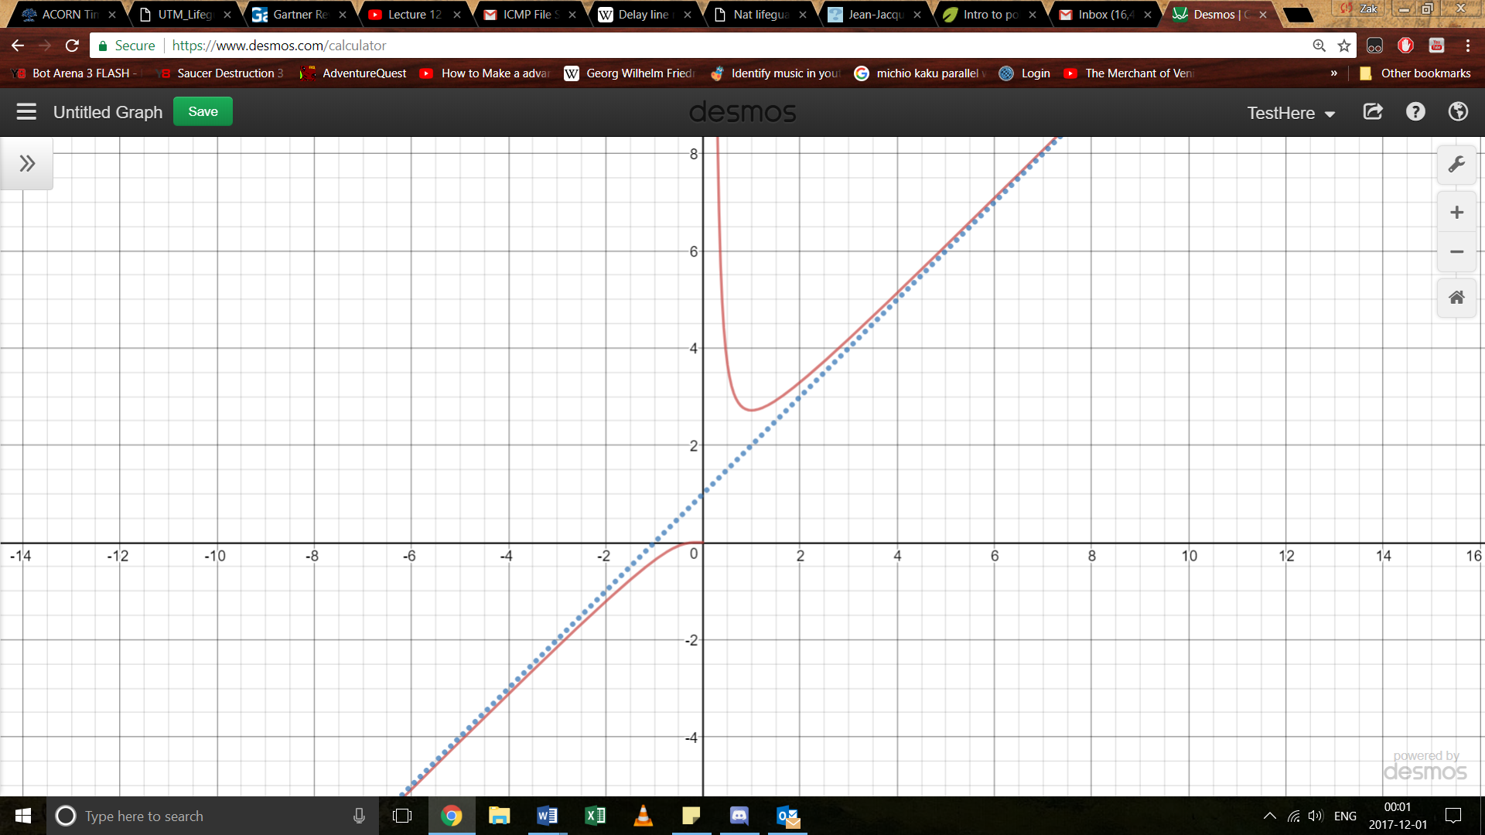

In simpler equations, you could do long division ex:

The oblique asymptote would be 2x-1

This could also be done for non linear functions like sin(x)

# **Derivatives to memories**

These are derivative that you’re allowed to use on your exam without proving, and might even be expected to use them. Note that inverse function must be defined on a limited domain and co-domain, or else it wouldn’t be bijective, and you can’t take its inverse (look at bijection paper if confusing)

* For , sin must be defined on the injective interval , or any equivalent
* For , cos must be defined on the injective interval , or any equivalent

You MUST state this if you want to take the inverse of a trig function, or else it technically wouldn’t be defined. Also, some of these functions where proven in this document, and you must also know their proof. They will be indicated by a star here.

Trig:

|  |  |  |  |
| --- | --- | --- | --- |
|  |  |  |  |
|  |  |  |  |
|  |  |  |  |

|  |
| --- |
| others |
|  |
|  |
|  |

# **Failures of differentiability**

1. is not continuous at a certain point

There’s a jump discontinuity

1. Left and right limit do not coincide
2. The slop of the tangent is not defined, since the line is vertical.

1. You need to memorise this. You could prove this using L’Hôpital’s rule or a fancy application of the squeeze theorem (video on khan academy explaining)
2. However, wouldn’t that mean that we force loose information here? (tyler)
3. Tyler decided that switching dx and dy would be a good lesson for the students. I just switched it back bc I don’t need the added complexity.
4. Don’t start plugging function that break the suppositions